Practicum No.8 Date:5/10/2026
Implementation of Unification in Logic Systems

- Practical Significance (with respect to practicum no. 1)
Unification is a key process in automated reasoning, enabling inference engines to match and substitute variables in logical expressions. It plays a critical role in Prolog interpreters, expert systems, and AI theorem provers by making logical connections between different predicates.
Industry-Relevant Job Positions:
- Logic Programming Engineer
- Knowledge Representation Specialist
- AI Research Assistant
- Rule-Based System Developer
- Competency and Industry-Specific Practical Skills (Kindly copy from the Course Structure)
This practicum exercise is expected to develop the following skills for the industry-identified competency.
- Use the principles of artificial intelligence to solve complex engineering problems.

(copy 2 to 4 skills from the above industry-specific skills)
- Apply logical reasoning and knowledge representation methods for building rule-based systems and intelligent agents. (Cognitive Domain)
- Use probabilistic reasoning models, such as Bayesian networks, for decision-making under uncertainty. (Cognitive Domain)
- Interpret AI model outcomes and ensure explainability in decision-making systems. (Cognitive Domain)
- Demonstrate accountability and professionalism while working in interdisciplinary AI development teams. (Affective Domain)
- Relevant CO(s) (Kindly copy from the Course Structure)
CO3. Use suitable knowledge representation techniques for AI-based applications.

- Practical Outcome (PrO) (Kindly copy from the Course Structure)
Develop the Unification Algorithm for the given logical expressions and demonstrate its application.

- Related ADO(s) (Kindly copy from the Course Structure)

- Follow ethical practices in AI model development and deployment.
- Follow adaptability to emerging AI techniques and technologies.
- Follow a structured approach to AI driven decision making.
- Follow a commitment to continuous learning.
- Minimum Underpinning Theory (Theory should be written only to relate this practicum)
Unification is the process of making two logical expressions identical by finding suitable substitutions for variables. It is a key mechanism for inference in FOL systems. A unifier is a set of substitutions that, when applied, makes the expressions equal.
Unification is a process in logic and AI used to make two logical expressions identical by finding a suitable substitution of variables.
It is fundamental in:
- Automated reasoning
- Theorem proving
- Logic programming (e.g., Prolog)
Key Concepts:
- Variable Matching: Replaces variables with constants or other variables to make terms equal.
- Substitution: A mapping of variables to terms.
- Occurs Check (not included in the sample): Ensures variables do not end up referring to expressions containing themselves.

- Practicum Set-up/Circuit Diagram/Algorithm/Flowchart (Copy and paste the probable set-up of the machines)
Algorithm:
- Input: Two logical expressions (e.g., expr1, expr2) as lists of symbols.
- Check Length: If expressions have different lengths, unification is not possible.
- Initialize Substitution Map: An empty dictionary to store variable substitutions.
- Compare Each Element:
If elements are equal → move to next.
If one is a variable (lowercase), map it to the constant or other term.
If both are constants and unequal → unification fails.
- Return: Substitution dictionary if unification is successful, else None.

Example: Basic unification function to compare predicates.
Prolog Sample Code:
student(alice).
student(bob).
student(charlie).

department(alice, cse).
department(bob, ece).
department(charlie, cse).

completed(alice, programming).
completed(alice, ai).

completed(bob, programming).

completed(charlie, programming).
completed(charlie, ai).

registered(alice, ai).
registered(alice, ml).

registered(bob, ml).
registered(charlie, ai).

Sample Rules
eligible_for_ai_lab(Student) :-
department(Student, cse),
completed(Student, programming),
completed(Student, ai).
eligible_for_ml_lab(Student) :-
department(Student, cse);
completed(Student, ml).
ai_ml_learner(Student) :-
registered(Student, ai);
registered(Student, ml).
advanced_course(Student) :-
department(Student, cse),
completed(Student, programming).
recommended_for_ai_lab(Student) :-
eligible_for_ai_lab(Student),
registered(Student, ai).

- Resources Required

S. No. | Name of Resource | Suggested Broad Specification | Quantity
- 1 | Computer System | Intel i5 or higher, 8 GB RAM, 256 GB SSD, Python 3.x installed | 1 per student
- 2 | Python Programming Environment | Python 3.x with standard libraries (NumPy, time module) | Installed
- 3 | Jupyter Notebook or IDE (e.g., VSCode, PyCharm) | For writing and running Python code | 1 per student

- Safety Precautions
- Avoid sharing login credentials.
- Ensure antivirus software and firewalls are updated.
- Keep eatables away from computers.
- Follow Institutional laboratory policies.
- Avoid storing confidential data in lab computers.
- Procedure
- Interpret the algorithm in Section VII to understand the unification algorithm.
- Specify the format of the input expressions, ensuring they are valid predicates with matching arity and syntactic structure.
- Plan the steps of unification: comparing terms, detecting variables, and storing substitutions in a mapping.
- Load the development environment (e.g., Jupyter Notebook, Google Colab, or any Python IDE) for coding and testing the algorithm.
- Initialize a substitution map (dictionary) to track variable-to-constant or variable-to-variable mappings.
- Compare each corresponding term from the two expressions using a loop, checking for identical terms or variables.
- Handle substitutions where variables are matched with constants or other variables while preserving consistency.
- Detect conflicts such as mismatched constants that cannot be unified and return failure if unification is not possible.
- Return the substitution dictionary if successful, and display the resulting unifier.
- Test the function with diverse expression pairs including variables, constants, and nested terms to validate flexibility.
- Measure execution time using Python’s time module to assess the efficiency of the unification algorithm.
- Analyze performance on increasingly complex logical expressions to understand scalability.
- Visualize test results using tables or charts to show which inputs successfully unified and the substitutions generated.
- Document the experiment, including input cases, unification results, failure reasons, and performance data.
- Actual Resources Used (To be filled by the students)

S. No | Name of Resource | Broad Specifications |  | Quantity | Remarks (If any)
S. No | Name of Resource | Make | Details | Quantity | Remarks (If any)
- 1 | Operating System | Microsoft | Windows 11 | 1 | -
- 2 | Programming Language | SWI-Prolog | Prolog logic programming language | 1 | -
- 3 | Software Development Kit | SWI-Prolog | SWI-Prolog interpreter and development environment | 1 | -
- 4 | Libraries | Built-in Prolog | Standard predicates and logical operators | 1 | -
- 5 | Graphics/Animation tool | Not used | - | 0 | -
- 6 | Front-end tool | Not used | - | 0 | -
- 7 | Back-end tool | SWI-Prolog | Executes facts, rules, and unification queries | 1 | -
- 8 | Virtual Lab | Not used | - | 0 | -
- 9 | Specific Hardware | Lenovo laptop | Computer system used to run SWI-Prolog | 1 | -
- 10 | Simulation/Emulation Tool | SWI-Prolog console | Tests aquarium facts, rules, and queries | 1 | -

- Actual Procedure Followed (To be filled by the students on the left page)

- Opened SWI-Prolog and created the Prolog source file prac.pl.
- Entered the facts and rules for the Smart Aquarium Management System.
- Saved the source file in the Prolog folder.
- Loaded the program using the consult/1 command.
- Executed queries to identify fish and their tank locations.
- Checked tank temperature and oxygen conditions.
- Tested the rules for safe tanks and fish requiring feeding.
- Executed the safe_fish/1 and monitor_fish/1 queries.
- Performed unification tests using variables and constants.
- Observed and recorded successful substitutions and failed unification results.

- Results/Obervations (To be filled by the students on the left page if space is not sufficient)

- The query fish(X) returned goldfish, betta, and guppy.
- The query in_tank(X, tank1) returned goldfish and guppy.
- The query safe_tank(X) returned tank1.
- The query needs_feeding(X) returned betta.
- The query needs_attention(X) returned tank2.
- The query safe_fish(X) returned goldfish and guppy.
- The query monitor_fish(X) returned betta.
- The unification query fish(X) = fish(betta) returned X = betta.
- The query fish(goldfish) = fish(betta) returned false, because the fish names do not match.

- Results/Observations (To be filled by the students)

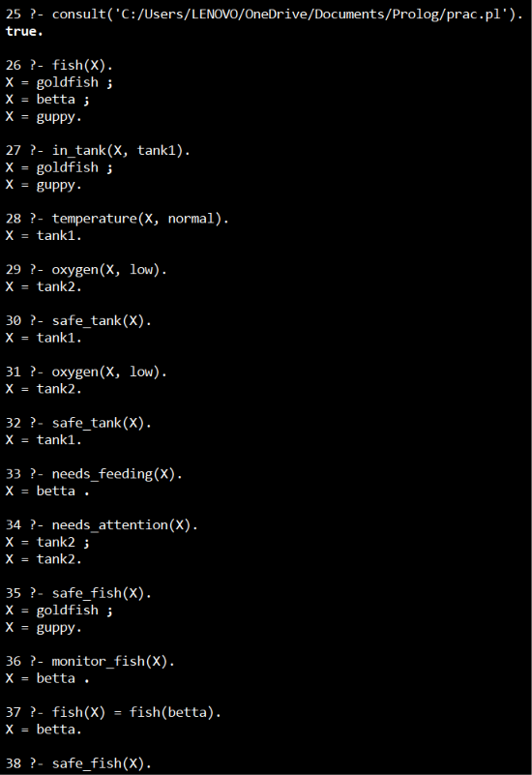
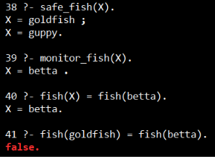

- Interpretation of Results (Students to state the meaning of the above-obtained results/observations)

The results demonstrate that Prolog uses unification to match variables with facts in the knowledge base. The rules identify safe tanks, fish that need feeding, and fish that require monitoring. When two predicates contain matching structures and compatible arguments, unification succeeds. When corresponding constants differ, unification fails.

- Conclusions (Students to draw conclusions (or take decisions) based on the interpretation of results).

The Smart Aquarium Management System was implemented using Prolog facts, rules, and unification. The queries successfully identified fish, tank conditions, feeding requirements, and monitoring needs. The experiment demonstrates how logic programming supports knowledge representation and rule-based reasoning in an intelligent aquarium management application.

- Suggested Practicum Related Questions:
Note: Below given are a few sample questions for reference. Teachers must design more such questions in order to ensure the achievement of pre-determined course outcome.
- What is unification in the context of logical inference and how does it support rule-based reasoning in AI?
- How does the implemented unification algorithm handle variable substitutions and conflicts between terms?
- Explain the difference between syntactic and semantic unification with examples.
- What are the conditions for two logical expressions to be unifiable?
- Describe how the algorithm handles expressions with nested structures or multiple variables.
- What challenges can arise when unifying predicates with different arities or function symbols?
- How can the unification process be integrated into expert systems or Prolog-based environments?
- Evaluate the time complexity of your unification algorithm and suggest optimizations.
- How does unification contribute to backward and forward chaining in inference engines?
- Can unification be extended to support fuzzy or probabilistic reasoning in AI systems

- References / Suggestions for further reading
Online Tutorials & Articles
- GeeksforGeeks – Unification in AI- https://www.geeksforgeeks.org/unification-in-artificial-intelligence/
- Javatpoint – Unification in AI- https://www.javatpoint.com/unification-in-ai

Interactive Platforms for Practicing Sorting Problems
- HackerRank – Artificial Intelligence (AI) Challenges- https://www.hackerrank.com/domains/tutorials/10-days-of-artificial-intelligence
- Codecademy – Learn Prolog- https://www.codecademy.com/learn/learn-prolog
Video Lectures & Courses
- Coursera – Logic for Artificial Intelligence by Stanford University- https://www.coursera.org/learn/logic-introduction
- Learn Prolog Programming (University of York)
https://www.youtube.com/playlist?list=PLz6Zc7J2M52V8HgLsovlfoU7cLgfjLPF6

- Suggested Assessment Scheme
The given performance indicators should serve as a guideline for assessment regarding process and product-related marks.
Note: The weightage for the process-related skills and product-related skills will change depending upon the PrO, COs, and competency related to the concerned course.

Performance indicators |  | Max. Marks | Marks Obtained
Process related skills: 18 Marks - 60%
 | Understanding of Unification Mechanism: | 3
 | Efficient Algorithm Design | 6
 | Followed Coding Standards and Best Practices | 6
 | Code Optimization | 3
Product related skills: 12 Marks - 40%
 | Correctness of Unification | 3
 | Handling Different Logical Expressions: | 3
 | Error Handling & Debugging | 1.5
 | Interpretation of Results and Conclusions | 1.5
 | Practical related questions | 1.5
 | Submitting the Report on time | 1.5
 | Total | 30

To be filled by Student:

S.No. | Name of the Student | Register No.
1 | SHREYA GEORGE | URK25CS1204

To be filled by the Faculty Member:
Marks Obtained |  |  | Name and Designation of the Faculty Member | Date of Evaluation
Process-Related Skills  (18) | Product-Related Skills (12) | Total  (30)

